LAB 11

FA17bece0024
Muhammmad Afzal
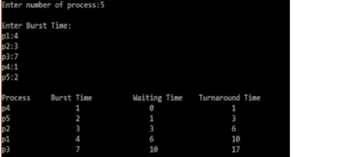

CODE:

include<stdio.h>
int main()
{
int bt[20],p[20],wt[20],tat[20],i,j,n,total=0,pos,temp;
float avg_wt,avg_tat;
printf("Enter number of process:");
scanf("%d",&n);

printf("nEnter Burst Time:n");
for(i=0;i<n;i++)
{
printf("p%d:",i+1);
scanf("%d",&bt[i]);
p[i]=i+1;
}

/sorting of burst times
for(i=0;i<n;i++)
{
pos=i;
for(j=i+1;j<n;j++)
{
if(bt[j]<bt[pos])
pos=j;
}

temp=bt[i];
bt[i]=bt[pos];
bt[pos]=temp;

temp=p[i];
p[i]=p[pos];
p[pos]=temp;
}

wt[0]=0;

for(i=1;i<n;i++)
{
wt[i]=0;
for(j=0;j<i;j++)
wt[i]+=bt[j];
total+=wt[i];
}

avg_wt=(float)total/n;
total=0;

printf("nProcesst Burst Time tWaiting TimetTurnaround Time");
for(i=0;i<n;i++)
{
tat[i]=bt[i]+wt[i];
total+=tat[i];
printf("np%dtt %dtt %dttt%d",p[i],bt[i],wt[i],tat[i]);
}

avg_tat=(float)total/n;
printf("nnAverage Waiting Time=%f",avg_wt);
printf("nAverage Turnaround Time=%fn",avg_tat);
}

